Maksim Razuvaev’s Website specification
Goal of the website is to show my skills in website development and introduce myself as specialist.
Website consists of five major pages:
- Home
- Resume
- Interests
- Reflections
- Guestbook
Each page has navigation bar on the top:
Screenshot 1

Each page has footer navigation bar:
Screenshot 2

Resume, Interests, Reflection, and Guestbook pages have the art picture on the top under navigation bar:
Screenshot 3
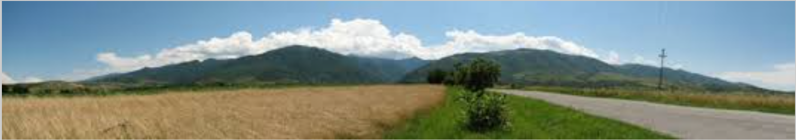
Home page
Home page contents my introduction, photo, and two external links to my favorite site.
Screenshot 4
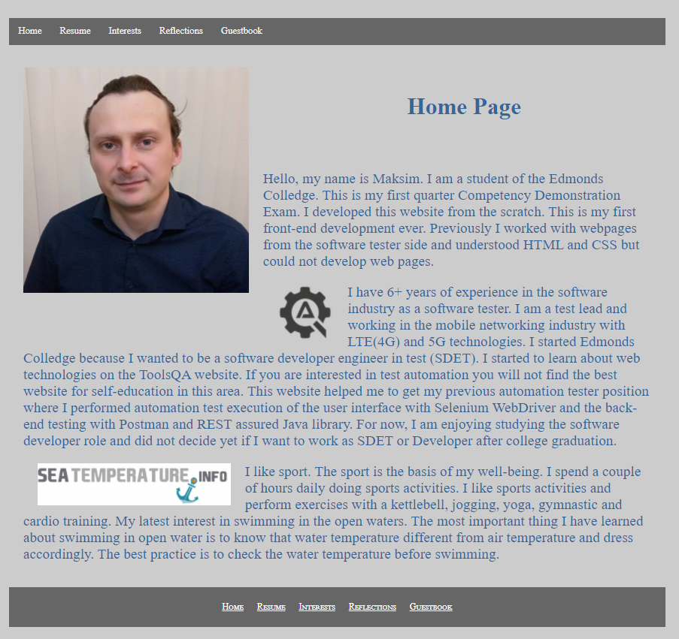

Resume
Resume page contents table with job related information and has four major sections:
- Desired Job Description
- Current Skills
- Employment History
- Education
Screenshot 5
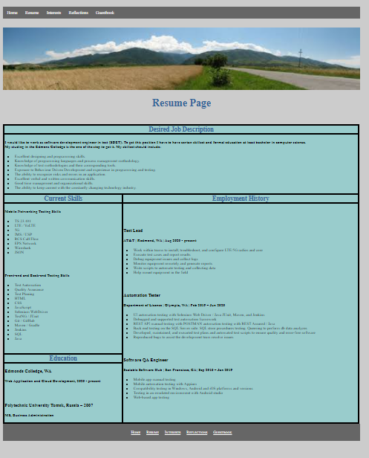
Interests
Interests page contents paragraph with unordered list of my interests. Each bullet of the unordered list begins with the link to the external website. Link opens website in the new tab.
Screenshot 6
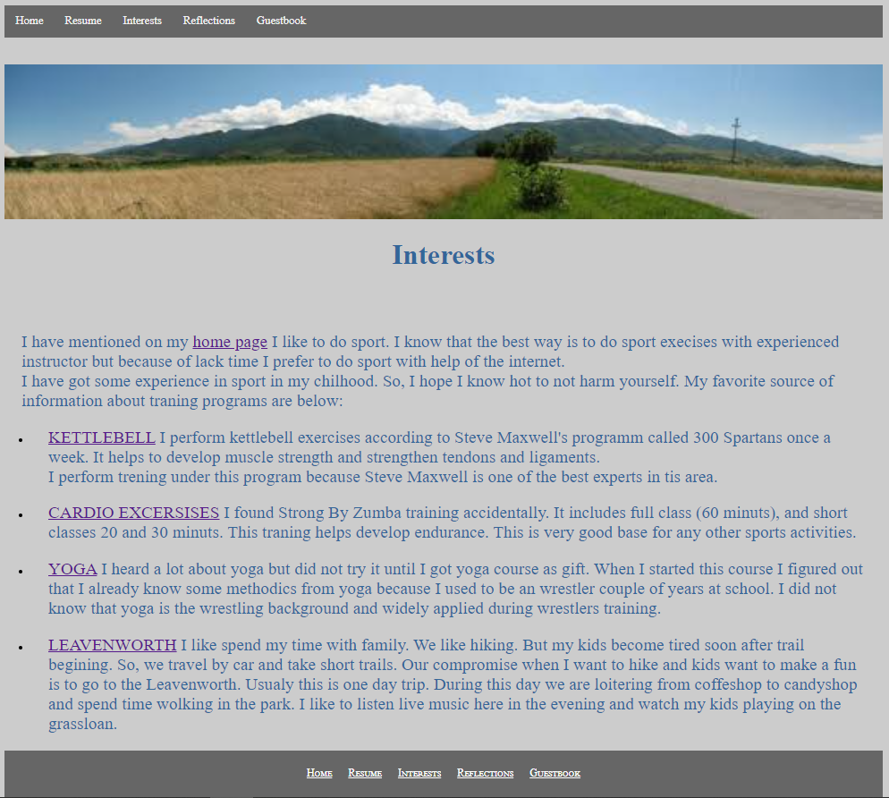

Reflection
Reflection page contents my reflection about my CIS 241 experience.
Screenshot 7
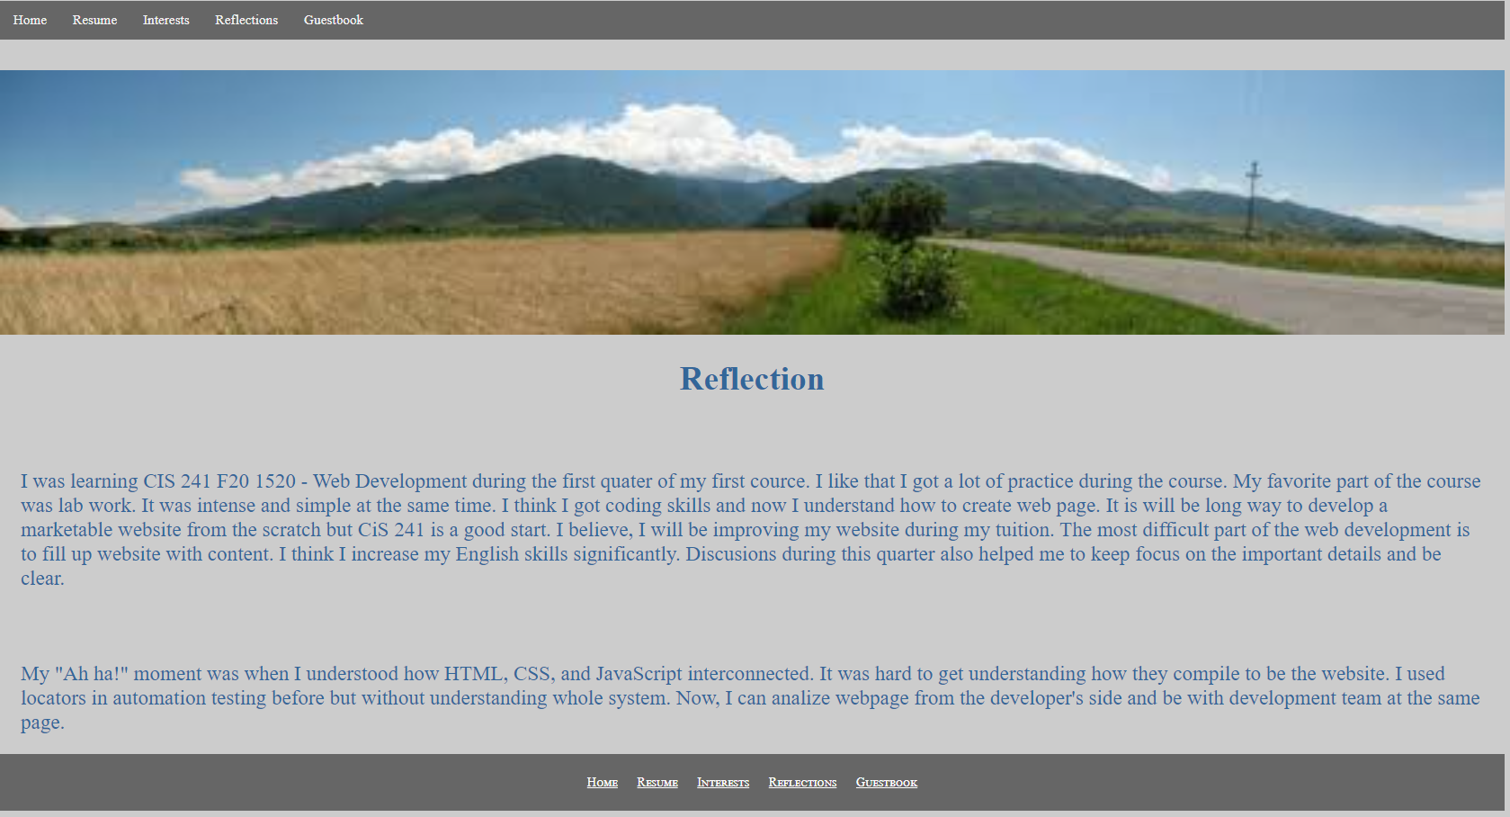

Guestbook
Guestbook page contents form with visitor questionnaire.
Screenshot 8
